**HOTEL RESERVATION**

**SYSTEM**

**Object Design**

**Document**

26.07.2016

P.MELİS DELİPINAR

YAĞIZ ŞENER

ONUR CİMŞİT

ORHUN BÜYÜKAYDIN

**Prepared for**

**SE301 Software Engineering**

Table of Contents

1. Introduction 3

1.1. Object Design Trade-offs 3

1.2. Interface Documentation Guidelines 3

1.3. Definitions, Acronyms, and Abbreviations 4

1.4. References 4

2. Packages 4

3. Class Interfaces 4

**OBJECT DESIGN DOCUMENT**

**1. Introduction**

## 1.1 Object Design Trade-offs

The project name is: Hotel Reservation System. This website is about: Booking. The purpose of this document is to describe design and architecture of the "HotelReservation" site. All code in this system is our own original work, including data and user interfaces. We use the database to keep information. The objective of the system is to be simple, but also to cover every detail and function needed by HotelReservationSystem. Therefore database increase security in system. System some keep some information like address, password, username securely.

**1.2 Interface Documentation Guidelines**

In this system, object-design principle had applied. There are two groups of graphical design in this project. First graphical design was made for User side and the other was made for Admin side. User panel has also two groups; User and Hotel User. These two designs are similar to each other.

On the user side, there are some of criterias. For instance; user may understand the site easily and do his/her actions easily on the site, also can done their reservations easily. The side should be understandable. In addition, Hotel User can see the reservations that are done by a user and The Hotel User can check the user’s information who had done a reservation. Hotel User also can add a hotel to the system by an admin approval.

The Admin panel, is more complex according to user-side. However, it is also easy to use for an admin. Menus are clearly identified on the panel. An admin can check all users’ information, can approve/reject hotel addition requests and user comments for reservations. In addition, an admin can send messages to hotel users before accepting/rejecting a hotel addition request.

**1.3 Definitions, Acronyms and Abbreviations**

- Database: Database is a collection of information that is organized so that it can easily be accessed

- ID : Identification

- Login: to get access to an operating system or application, usually in a remote computer

- ODD : Object Design Document

- UI : User Interface

- Server: is a computer,provides services to other computers

- User: a person who use a computer

- Exception: Represents errors that occur during application execution.

- Error: The condition of having incorrect or false knowledge.

**1.4 References**

- http://searchsqlserver.techtarget.com/definition/database

- http://dioscuri.sourceforge.net/docs/ODD_Dioscuri_KBNA_v1_1_en.pdf

**2. Packages**

2.1 db

2.1.1 hotel

2.1.2 hotelroom

2.1.3 reservation

2.1.4 user

**3. Class Interfaces**

**3.1.1 user.java**

This class explains and shows the contents about user functions.

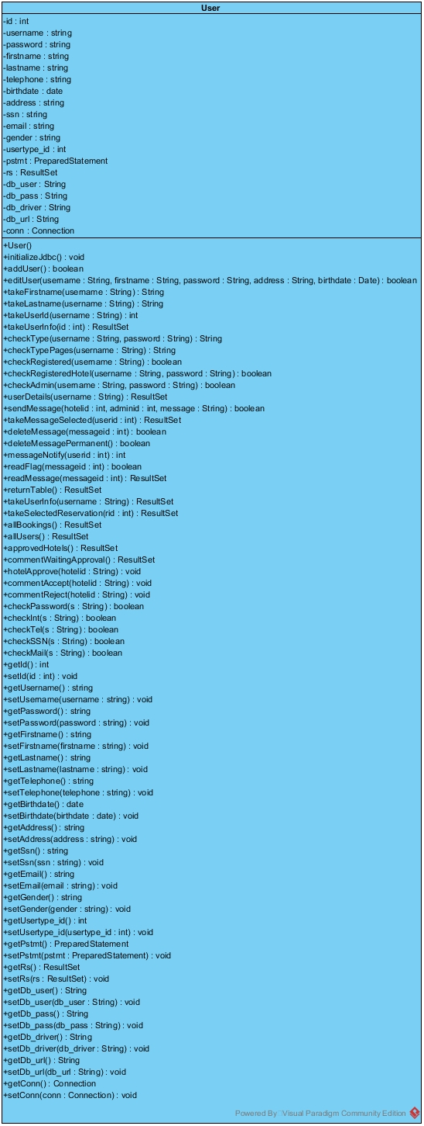

**3.1.2 hotel.java**

This class explains and shows the contents about hotel functions.

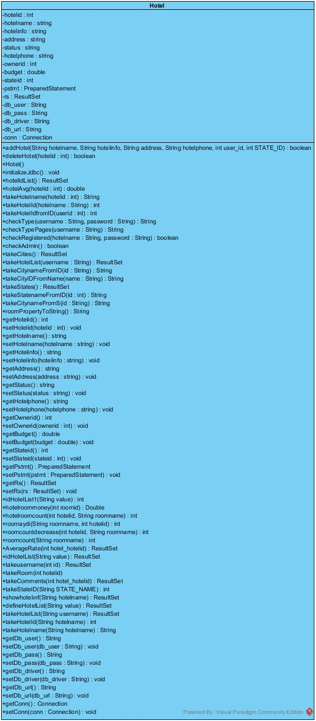

**3.1.3 reservation.java**

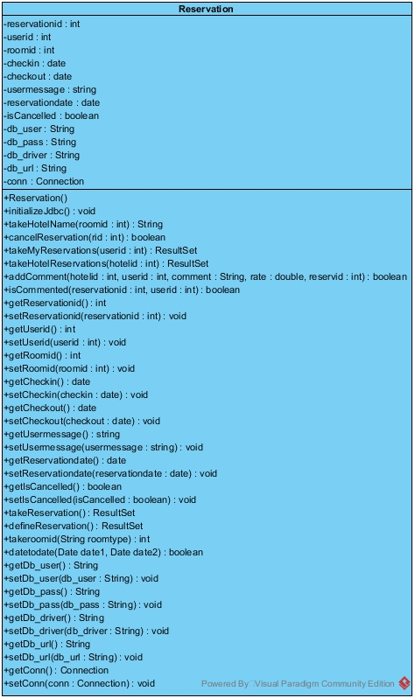This class explains and shows the contents about reservation functions.

**3.1.4 hotelroom.java**

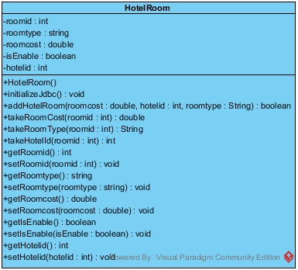This class explains and shows the contents about hotelroom functions.